Materiały z języka angielskiego dla 5-6 latków
Zestaw słówek angielskich o tematyce ANIMALS ON THE FARM

Barn – stodoła
Goat – koza
Cow- krowa
Duck – kaczka
Chicken – kurczak
Pig- świnia
Horse – koń
Sheep – owca
Rabbit -królik

Link do filmiku z nazwami zwierząt - https://www.youtube.com/watch?v=bV8MSaYlSbc

Piosenka - https://www.youtube.com/watch?v=zXEq-QO3xTg

Song lyrics
The ducks on the farm say, “Quack, quack, quack.”
The mice on the farm say, “Squeak, squeak, squeak.”
The chickens on the farm say, “Cluck, cluck, cluck.”
“Quack. Squeak. Cluck.”
The pigs on the farm say, “Oink, oink, oink.”
The goats on the farm say “Meh, meh, meh.”
The sheep on the farm say “Baa, baa, baa.”
“Oink. Meh. Baa.”
The horses on the farm say, “Neigh, neigh, neigh.”
The cows on the farm say, “Moo, moo, moo.”
The roosters on the farm say, “Cock-a-doodle-doo.”
“Neigh. Moo. Cock-a-doodle-doo.”
“Neigh. Moo. Cock-a-doodle-doo.”
Let’s try it a little faster.
The ducks on the farm say, “Quack, quack, quack.”
The mice on the farm say, “Squeak, squeak, squeak.”
The chickens on the farm say, “Cluck, cluck, cluck.”
“Quack. Squeak. Cluck.”
Okay, a little faster.
The pigs on the farm say, “Oink, oink, oink.”
The goats on the farm say “Meh, meh, meh.”
The sheep on the farm say “Baa, baa, baa.”
“Oink. Meh. Baa.”
Okay, super fast!
The horses on the farm say, “Neigh, neigh, neigh.”
The cows on the farm say, “Moo, moo, moo.”
The roosters on the farm say, “Cock-a-doodle-doo”
“Neigh. Moo. Cock-a-doodle-doo.”
“Neigh. Moo. Cock-a-doodle-doo.”

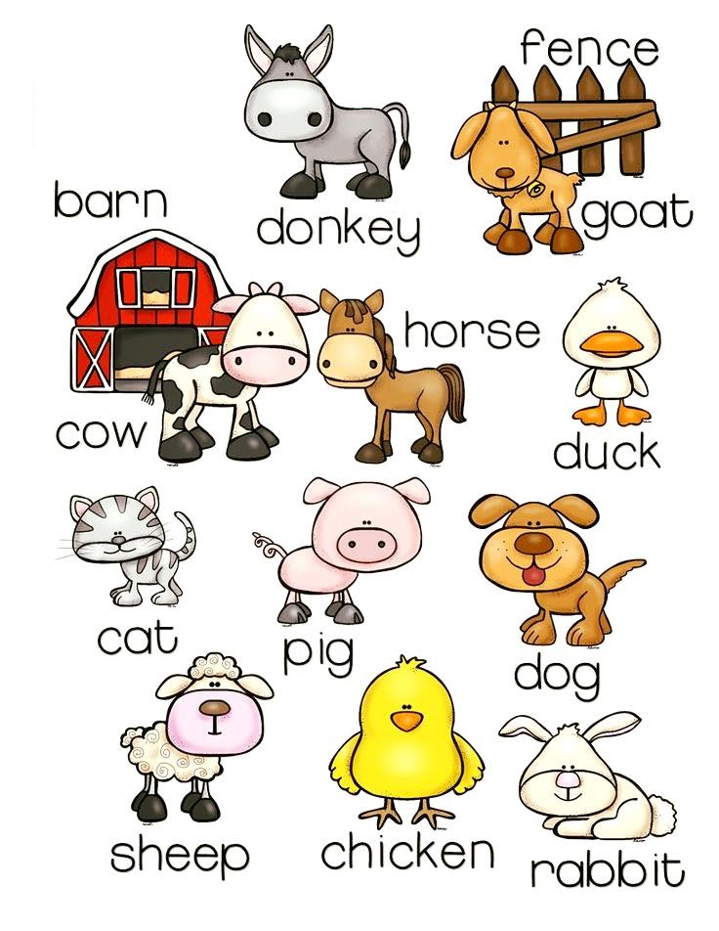

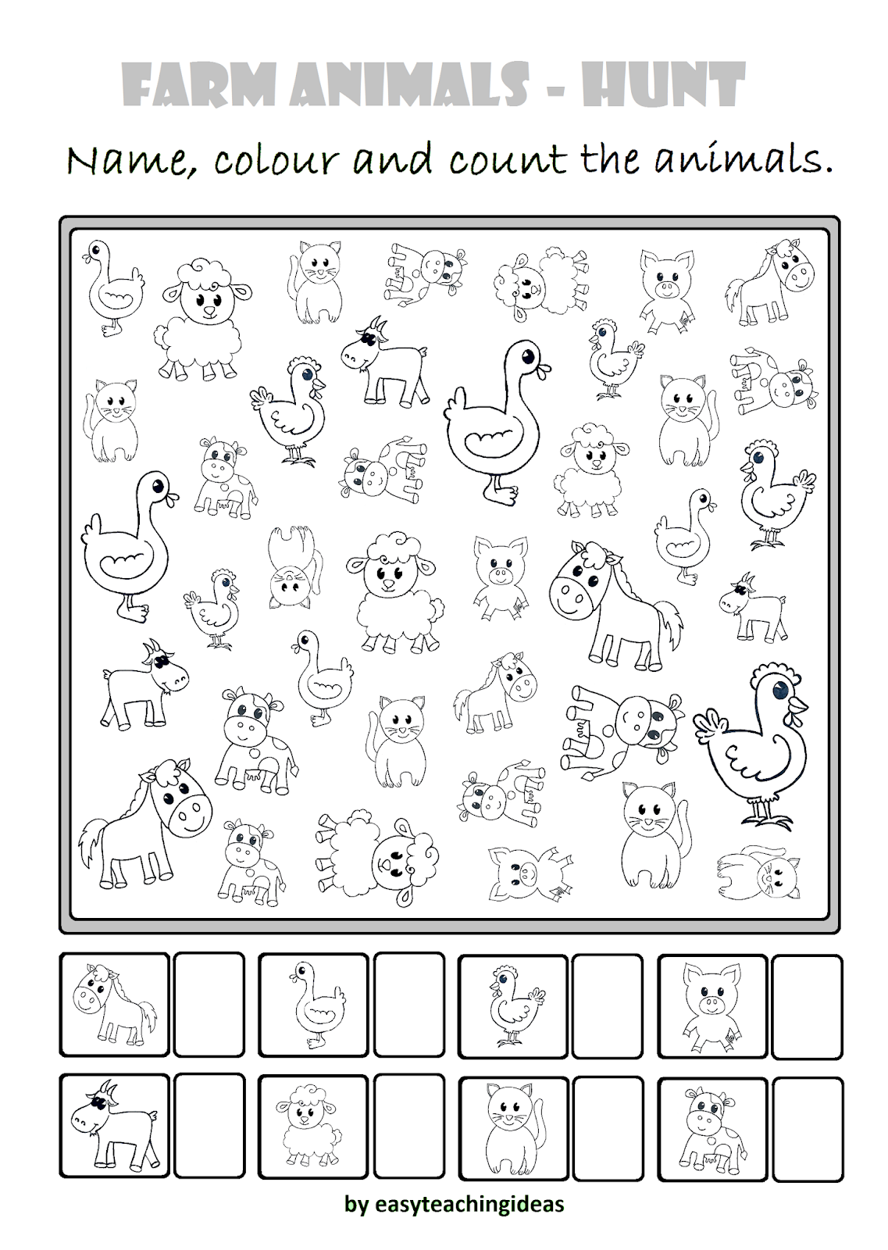
Zabawa dla chętnych – połącz nazwy angielskie z obrazkiem zwierzęcia - https://wordwall.net/pl/resource/7305899/angielski/farm-animals

